­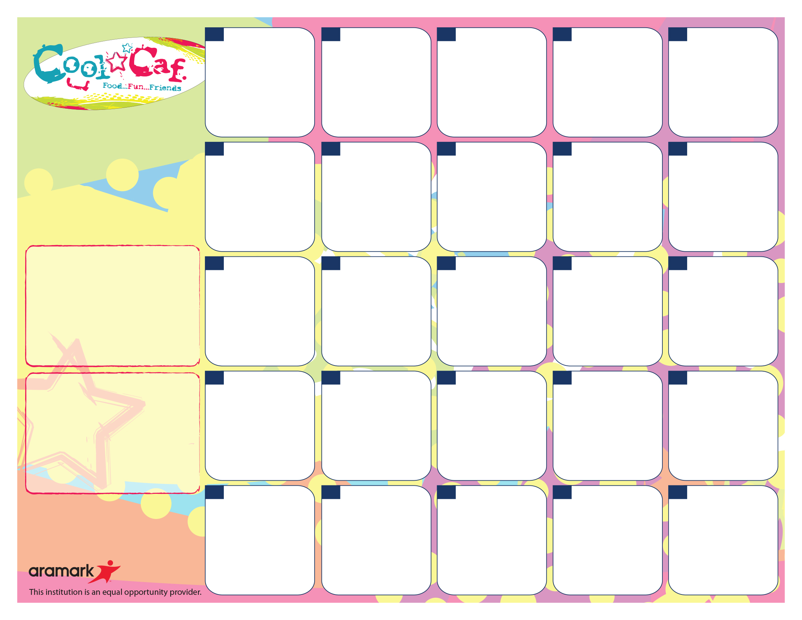

Warm Egg and Cheddar WG Wrap

4 oz, 100% Fruit Juice

AND

Fresh Fruit

**2**

WG Fluffy Pancakes w/ Syrup

4 oz, 100% Fruit Juice

AND

Fresh Fruit

WG Apple Fruit Strudel Stick

4 oz, 100% Fruit Juice

AND

Fresh Fruit

**30**



**28**



**Daily Breakfast Offerings**

WG Fresh Bagels w/Cream Cheese or Butter; WG Assorted Muffins

All-Natural Yogurt w/Granola or Fresh Fruit; Mozzarella Cheese Sticks

Assorted, WG Cereals w/Cheese Stick or Graham Crackers

*Fresh Fruit Daily at Breakfast, may be in Conjunction w/100% Fruit Juice*

*All Served w/Milk (Antibiotic & Hormone-Free 1% White and Skim*

For Summer Meal Information Call National Hunger Hotline at 1-866-3-HUNGRY or 1-877-8-HAMBRE

WG Apple Fruit Strudel Stick

4 oz, 100% Fruit Juice

AND

Fresh Fruit

**9**

Egg & Cheddar on WG English Muffin

4 oz, 100% Fruit Juice

AND

Fresh Fruit

**14**

Egg, Turkey Sausage & Cheese on WG Kaiser Roll

4 oz, 100% Fruit Juice

AND

Fresh Fruit

**10**

**29**

**25**



**24**

WG Waffles w/ Syrup

4 oz, 100% Fruit Juice

AND

Fresh Fruit

**7**

Ham & Egg on WG Kaiser Roll

4 oz, 100% Fruit Juice

AND

Fresh Fruit

**8**

**More info…**

If you have any questions, please call the Food Services Department at (914) 220-3038 or e-mail [Renken-Sandra@aramark.com](mailto:Renken-Sandra@aramark.com)

*Free or Reduced Breakfast Program. To Apply, Visit mamkschools.org/parents-community/food-services.

If your child has a food allergy, please contact your school nurse

**Breakfast pricing…**

$1.20 – Students / $2.25+Tax - Adults

Reduced = FREE – FRLP* Participants

Breakfast Includes:

Meat/Protein Alternate (varies daily), Bread/Grain, Fruit/Juice and Choice of Fat-Free White or 1% White (8 oz).

Regardless of portion size, the FSMC is responsible for meeting all requirements under the Final Rule Nutrition Standards in the National School Lunch and School Breakfast Programs. This includes Min-Max calories, Saturated Fat, Sodium, specific component offers for all fruits, vegetables, grains, meat/meat alternates and milk.

WG Waffles w/ Syrup

4 oz, 100% Fruit Juice

AND

Fresh Fruit

**21**

Ham & Egg on WG Kaiser Roll

4 oz, 100% Fruit Juice

AND

Fresh Fruit

**22**

Egg, Turkey Sausage & Cheese on WG Kaiser Roll

4 oz, 100% Fruit Juice

AND

Fresh Fruit

**23**

WG Apple Fruit Strudel Stick

4 oz, 100% Fruit Juice

AND

Fresh Fruit

**15**

Egg & Cheddar on WG English Muffin

4 oz, 100% Fruit Juice

AND

Fresh Fruit

**16**

WG Pancakes w/ Syrup

4 oz, 100% Fruit Juice

AND

Fresh Fruit

**17**

Egg, Turkey Sausage & Cheese on WG Kaiser Roll

4 oz, 100% Fruit Juice

AND

Fresh Fruit

**18**

Warm Cornbread

4 oz, 100% Fruit Juice

AND

Fresh Fruit

**11**

WG French Toast w/ Syrup

4 oz, 100% Fruit Juice

AND

Fresh Fruit

**3**

Egg & Cheese on WG English Muffin

4 oz, 100% Fruit Juice

AND

Fresh Fruit

**4**

Warm Cornbread

4 oz, 100% Fruit Juice

AND

Fresh Fruit

**1**

**Mamaroneck Avenue Elementary**

**Breakfast Menu**

**May 2018**