­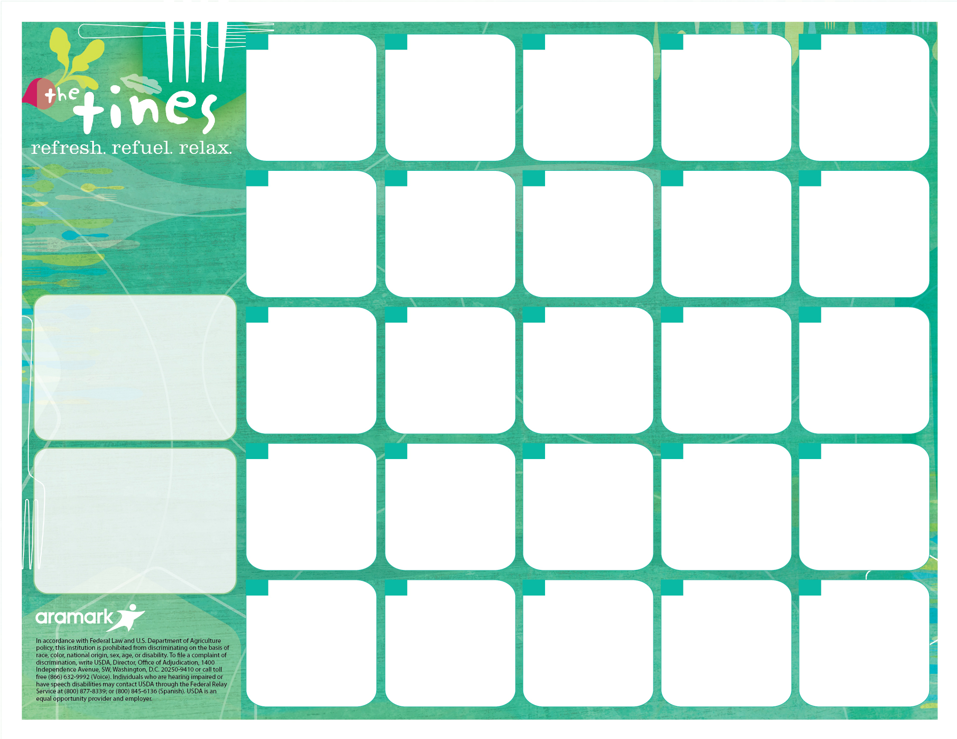

Whole Grain French Toast w/ Syrup

Turkey Bacon

4oz. 100% Fruit Juice

½ Cup Fresh Fruit

**15**

Ham, Egg, & Cheese on a Whole Gain Roll

4oz. 100% Fruit Juice

½ Cup Fresh Fruit

**21**



**29**

**Additional Breakfast Meal Options (Offered Daily)**

**Whole Grain Bagels** w/ butter or cream cheese

**Assorted Yogurts** w/ graham crackers

**Assorted Cereals** w/ cheese stick orgraham crackers

Corn Bread

Turkey Sausage Patty

4oz. 100% Fruit Juice

½ Cup Fresh Fruit

**23**

Whole Grain Fluffy Pancakes w/ Syrup

Turkey Bacon

4oz. 100% Fruit Juice

½ Cup Fresh Fruit

**23**



**2828**



**25**

**7**

**MUFSC**

**Mamaroneck High School**

**May 2018**

Whole Grain Waffle w/ Syrup

Turkey Bacon

+4oz. 100% Fruit Juice

½ Cup Fresh Fruit

**18**

Egg & Cheese on a Whole Grain English Muffin

Potato Bites

4oz. 100% Fruit Juice

½ Cup Fresh Fruit

**177**

Whole Grain Waffles w/ Syrup

Turkey Bacon

4oz. 100% Fruit Juice

½ Cup Fresh Fruit

**4**

Breakfast Sliders w/ Sausage, Egg, & Cheese

4oz. 100% Fruit Juice

1/2Cup Fresh Fruit

**24**

**24**

Breakfast Burrito w/ Ham, Egg, & Cheddar Cheese

4oz. 100% Fruit Juice

½ Cup Fresh Fruit

**7**

**Breakfast Pricing…**

$1.20 – Students / $2.20+Tax - Adults

$0.25 or FREE – FRLP* Participants

Water Stations are available with all meals

All Lunches Include:

Protein, Bread/Grain, Vegetable, Fruit and Choice of Fat-Free White, 1% White (8 oz), or 100% Juice (4oz).

*Fresh Fruit Basket Offered Daily.

Egg & Cheese on a Whole Grain English Muffin

Hash Brown Patty

4oz. 100% Fruit Juice

½ Cup Fresh Fruit

**3**

**More info…**

If you have any questions, please call Sandra Renken in the Food Services Dept. at (914) 220-3337

*Free or Reduced Lunch Program. To Apply, Visit mamkschools.org/parents-community/food-services.

If your child has a food allergy, please contact your school nurse.

Egg, Turkey Bacon, & Cheese on a Whole Grain Roll

4oz. 100% Fruit Juice

½ Cup Fresh Fruit

**30**

Corn Bread

Turkey Sausage Patty

4oz. 100% Fruit Juice

½ Cup Fresh Fruit

**16**

Whole Grain Fluffy Pancakes w/ Syrup

Turkey Bacon

4oz, 100% Fruit Juice

½ Cup Fresh Fruit

**9**

Egg, Turkey Sausage, & Cheese on a Whole Grain Roll

4oz. 100% Fruit Juice

½ Cup Fresh Fruit

**14**

**22**

Breakfast Sliders w/ Sausage, Egg, & Cheese

4oz. 100% Fruit Juice

½ Cup Fresh Fruit

**10**

Corn Bread

Turkey Sausage Patty

4oz. 100% Fruit Juice

½ Cup Fresh Fruit

**8**

Egg, Turkey Bacon, & Cheese on a Whole Grain Roll

4oz. 100% Fruit Juice

½ Cup Fresh Fruit

**1**

Egg, Turkey Sausage, & Cheese on a Whole Grain Roll

4oz. 100% Fruit Juice

½ Cup Fresh Fruit

**11**

Whole Grain French toast w/ Syrup

Turkey Sausage Patty

4oz 100% Fruit Juice

½ Cup Fresh Fruit

**2**