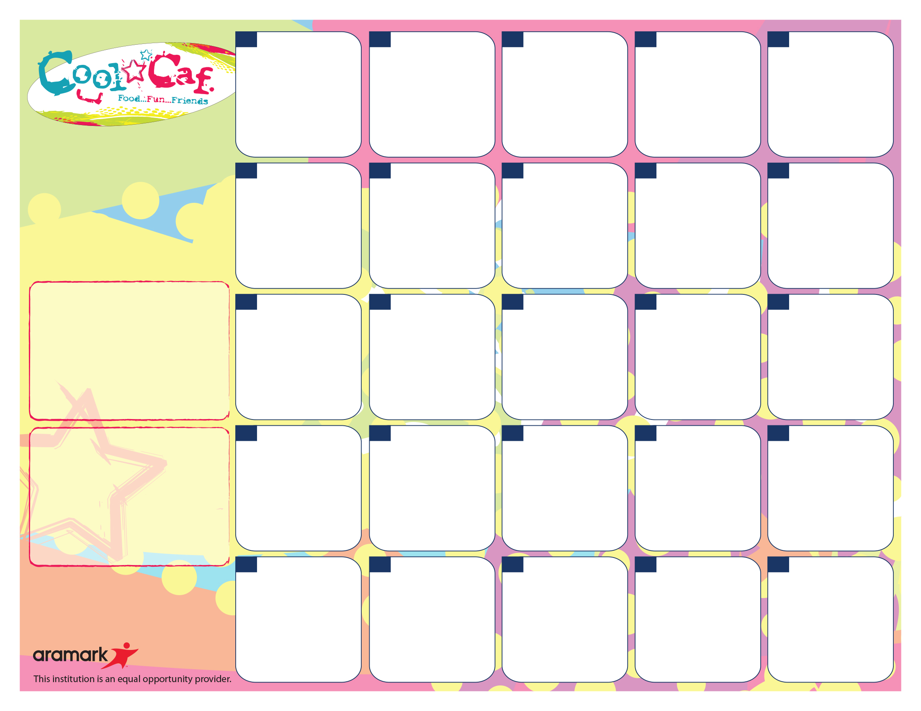

**Daily Lunch Offerings:**

Side Salad - 1 Cup Dark, Leafy Greens Topped w/Seasonal Produce

Fruits and Vegetables - A Variety of Fresh Fruits & Vegetables in 1/2 Cup Portions

Sunflower Seed Spread & Grape Jelly Sandwiches on WG Bread

Yogurt Parfait: All-Natural Yogurt w/Granola & Fruit

***\*\* Water stations are available with all meals*** WG=Whole Grain***

**Sandwiches w or w/o Cheese: Mon** – Turkey, **Tues**– Egg Salad, **Wed**– Salami (or Cheese Sand), **Thurs** – Roast Chicken Breast, **Fri** – Bologna.

**Salads: Mon** – Chef, **Tues** – Chicken Caesar, **Wed –**Tuna Salad**, Thurs –** Egg Salad, **Fri –** SW Chicken / Cheese

For Summer Meal Information Call National Hunger Hotline at 1-866-3-HUNGRY or 1-877-8-HAMBRE

Wellness Wednesday

Whole Grain Macaroni & Cheese

Spinach Salad

Carrot Coins

Cantaloupe Cuts

**Lunch pricing…**

$2.80 – Students / $3.75+Tax - Adults

Reduced =FREE – FRLP* Participants

Lunch Includes:

Protein, Bread/Grain, Vegetable, Fruit and Choice of Fat-Free White, Chocolate or 1% White (8 oz.).

Pay for School Meals. **Myschoolbucks.com**

Early Dismissal

No lunch will be served.

**23**







Meatball Sub

With Parmesan Cheese

Steamed Green Beans,

Cucumber & Tomato Salad

Fresh Fruit Salad

**27**

***Nacho Tuesday:***

Chicken Taco Meat w/ Corn Chips Rounds

1oz Cheese

Salsa & Sour Cream

Brown Rice

Black Bean & Sweet Corn

Banana

**24**

***Chicken Monday***

WG Chicken Tenders

Vegetarian Baked Beans

Seasoned Carrot Coins

Cantaloupe Cuts

***Burger Bonanza…***

Beef Burger or Veggie Patty on Whole Grain Roll

Sliced Lettuce & Tomato Salad

Vegetarian Baked Beans

Oven Fries

Bananas



**2**

**4**

**17**

**5**

**11**

***Breakfast for Lunch***

WG Waffles,

Turkey Sausage Patty

Sliced Cucumbers

Cinnamon Apple Sauce

Villa Maria Pizza

WG Breadstick

Carrot Sticks

Apple Slices

**26**

Wellness Wednesday

WG Rotini Pasta in a Pink Sauce

Thyme Seasoned White Beans

Steamed Broccoli

Watermelon

**18**

**16**



**25**

**Murray Elementary**

**School - April 2018**

**More info…**

If you have any questions, please call Sandra Renken in the Food Services Department at (914) 220-3038

*Free or Reduced Lunch Program. To Apply, Visit mamkschools.org/parents-community/food-services.

If your child has a food allergy, please contact your school nurse.

***South of the Border***

Baked Tostitos Scoops served with Seasoned Chicken Taco Meat with 1oz Cheese

Pinto Beans

Sweet Corn

Orange Wedges

Regardless of portion size, the FSMC is responsible for meeting all requirements under the Final Rule Nutrition Standards in the National School Lunch and School Breakfast Programs. This includes Min-Max calories, Saturated Fat, Sodium, specific component offers for all fruits, vegetables, grains, meat/meat alternates and milk.

**3**

***Chicken n’ Waffles***

Chicken Tenders, WG Waffles,

Roasted Yellow & Green Squash

Fresh Fruit Salad

**19**

**30**

Wellness to the Weekend

Baked Ziti w. Ricotta Cheese

Steamed Green Beans

Watermelon

**20**

***All American Lunch***:

Grilled Cheddar Cheese on WG Bread

Homemade Tomato Soup

Celery Sticks

Fresh Fruit Salad

***Chicken Monday***

WG Chicken Patty on or off the WG Bun

Served with Sweet Potato Puffs

Steamed Broccoli

Oranges

**9**



**6**

**133**

Villa Maria Pizza

WG Breadstick

Carrot Sticks

Apple Slices



**12**

***Taco Tuesday:***

Tacos w/Beef or Veggies w/ 1oz Cheese

Salsa & Guacamole

Brown Rice

Black Bean & Sweet Corn

Banana

**10**