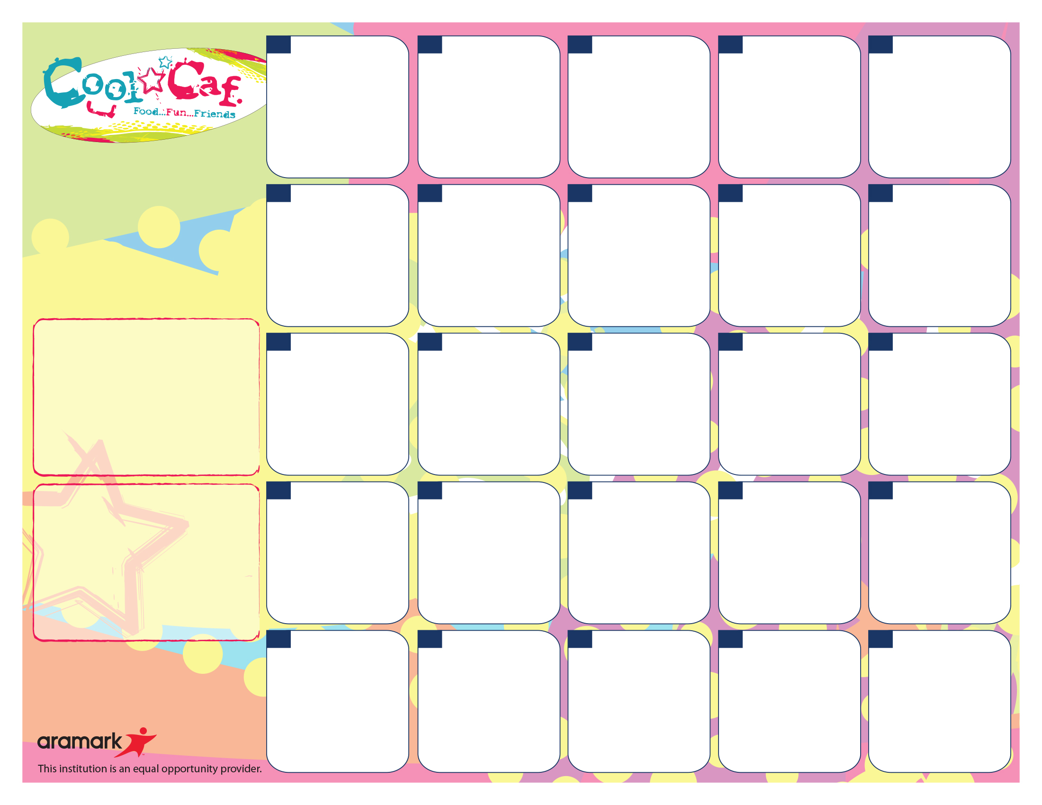

**Daily Lunch Offerings:**

Side Salad - 1 Cup Dark, Leafy Greens Topped w/Seasonal Produce

Fruits and Vegetables - A Variety of Fresh Fruits & Vegetables in 1/2 Cup Portions

Sunflower Seed Spread & Grape Jelly Sandwiches on WG Bread

Yogurt Parfait: All-Natural Yogurt w/Granola & Fruit

***\*\* Water stations are available with all meals*** WG=Whole Grain***

**Sandwiches w or w/o Cheese: Mon** – Turkey, **Tues**– Egg Salad, **Wed**– Salami (or Cheese Sand), **Thurs** – Roast Chicken Breast, **Fri** – Bologna.

**Salads: Mon** – Chef, **Tues** – Chicken Caesar, **Wed –**Tuna Salad**, Thurs –** Egg Salad, **Fri –** SW Chicken / Cheese

For Summer Meal Information Call National Hunger Hotline at 1-866-3-HUNGRY or 1-877-8-HAMBRE

***Nacho Tuesday:***

Chicken Taco Meat w/ Corn Chips Rounds

1oz Cheese

Salsa & Sour Cream

Brown Rice

Black Bean & Sweet Corn

Banana

**24**



**2**



***Breakfast for Lunch***

WG Waffles,

Turkey Sausage Patty

Sliced Cucumbers

Cinnamon Apple Sauce

Wellness to the Weekend

Baked Ziti w. Ricotta Cheese

Steamed Green Beans

Watermelon

***South of the Border***

Baked Tostitos Scoops served with Seasoned Chicken Taco Meat with 1oz Cheese & Salsa

Sweet Corn

Orange Wedges

***Burger Bonanza…***

Beef Burger or Veggie Patty on Whole Grain Roll

Sliced Lettuce & Tomato Salad

Vegetarian Baked Beans

Oven Fries

Bananas

**Lunch pricing…**

$2.80 – Students / $3.75+Tax - Adults

Reduced = FREE – FRLP* Participants

Lunch Includes:

Protein, Bread/Grain, Vegetable, Fruit and Choice of Fat-Free White, Chocolate or 1% White (8 oz.).

Pay for School Meals. **Myschoolbucks.com**

Early Dismissal

No lunch will be served

**23**

***Chicken n’ Waffles***

Chicken Tenders, WG Waffles, Roasted Squash

Fresh Fruit Salad

**199**

Meatball Sub in a WG Club Roll served with

Parmesan Cheese

Steamed Green Beans,

Fresh Fruit Salad

**26**

***Chicken Monday***

WG Chicken Tenders

Vegetarian Baked Beans

Seasoned Carrot Coins

Cantaloupe Cuts

5



**Chatsworth**

**Elementary**

**School**

**April 2018**

**27**

Villa Maria Pizza

WG Breadstick

Carrot Sticks

Sliced Apples



**18**

**16**

**17****12**

**25**

**21**

Wellness to the Weekend

WG Rotini Pasta in a Pink Sauce

White Bean Salad w. Thyme

Steamed Broccoli

Watermelon

**20**

**More info…**

If you have any questions, please call Sandra Renken in the Food Services Department at (914) 220-3038

*Free or Reduced Lunch Program. To Apply, Visit mamkschools.org/parents-community/food-services.

If your child has a food allergy, please contact your school nurse.

Regardless of portion size, the FSMC is responsible for meeting all requirements under the Final Rule Nutrition Standards in the National School Lunch and School Breakfast Programs. This includes Min-Max calories, Saturated Fat, Sodium, specific component offers for all fruits, vegetables, grains, meat/meat alternates and milk.

Villa Maria Pizza

WG Breadstick

Carrot Sticks

Sliced Apples



**11**



**4**

**3**

**30**

Wellness to the Weekend

Whole Grain Macaroni & Cheese

Spinach Salad

Carrot Coins

Cantaloupe Cuts

***Chicken Monday***

WG Chicken Patty with or without a WG Bun

Served with

Sweet Potato Tots

Steamed Broccoli

Oranges

**9**



**6**

**13**

***All American Lunch***:

Grilled Cheddar Cheese on WG Bread

Homemade Tomato Soup

Celery Sticks

Grapes

**12**

***Taco Tuesday:***

Tacos w/Beef or Veggies w/ 1oz Cheese

Salsa & Guacamole

Brown Rice

Black Bean & Sweet Corn

Banana

**10**