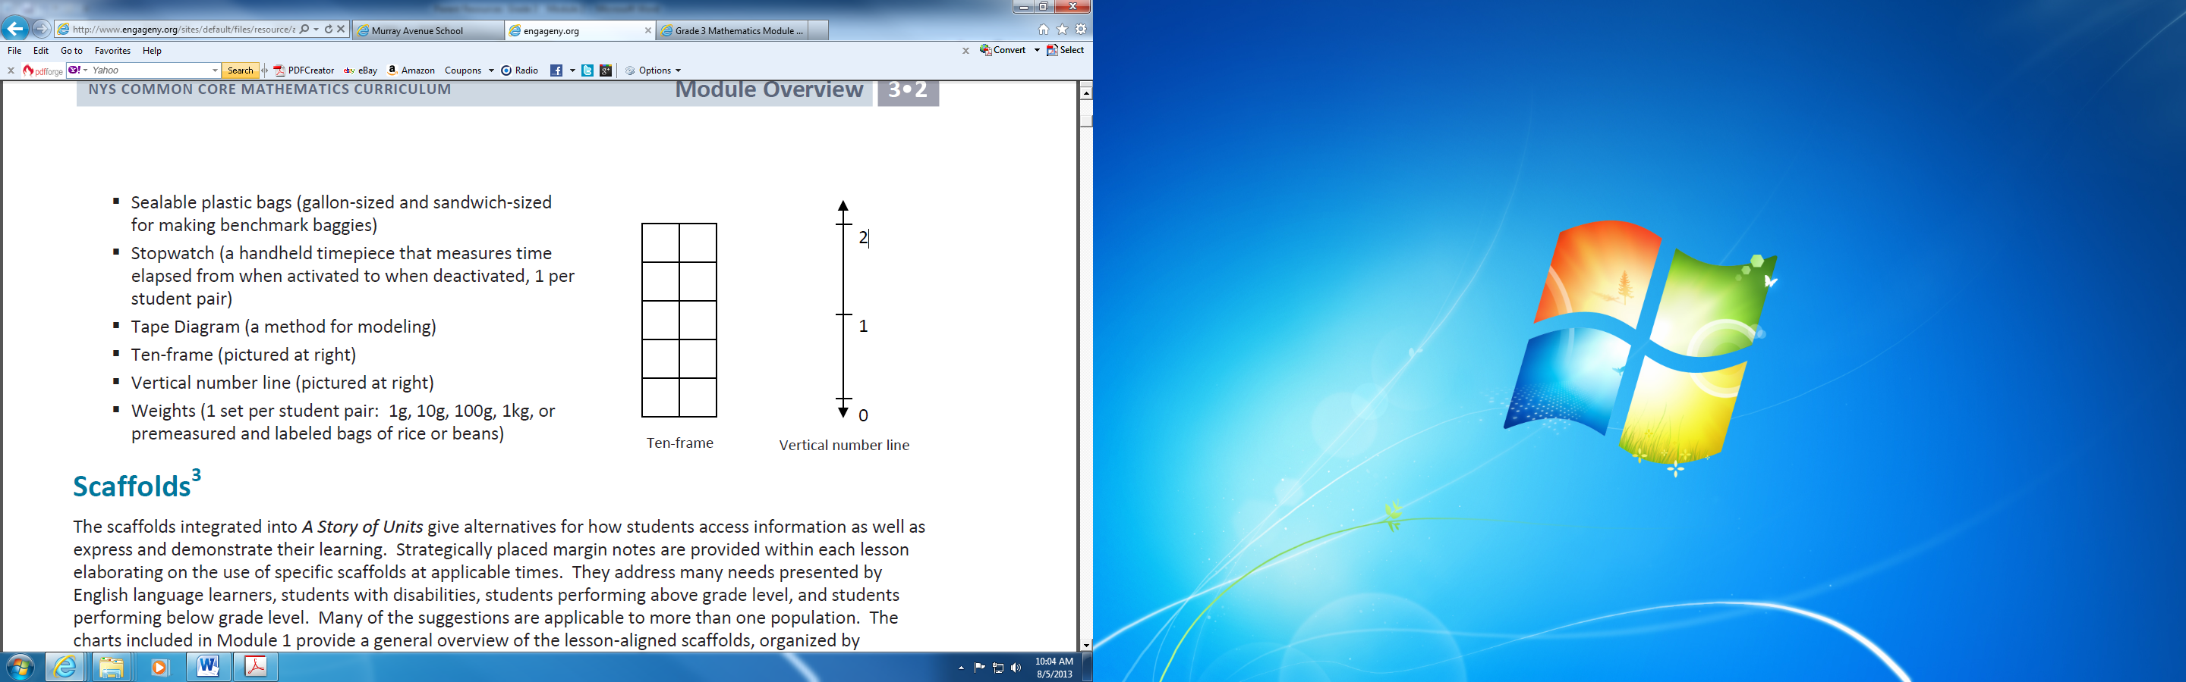***Examples of Concepts in Module 2: Third Grade***



The **number line** is used to develop a deeper understanding of whole number units, fraction units, measurement units, decimals, and negative numbers. The image shown demonstrates using a number line to show elapsed time.



The **number bond** is a pictorial representation of part-part-whole relationships and shows that within a part-whole relationship, smaller numbers (the parts) make up larger numbers (the whole).



5 when modeling algorithms and as a support for mental math with very large whole numbers

**Number disks** are units used to further develop place value understanding. Number disks are used by students when modeling algorithms and as a support for mental math with very large whole numbers.

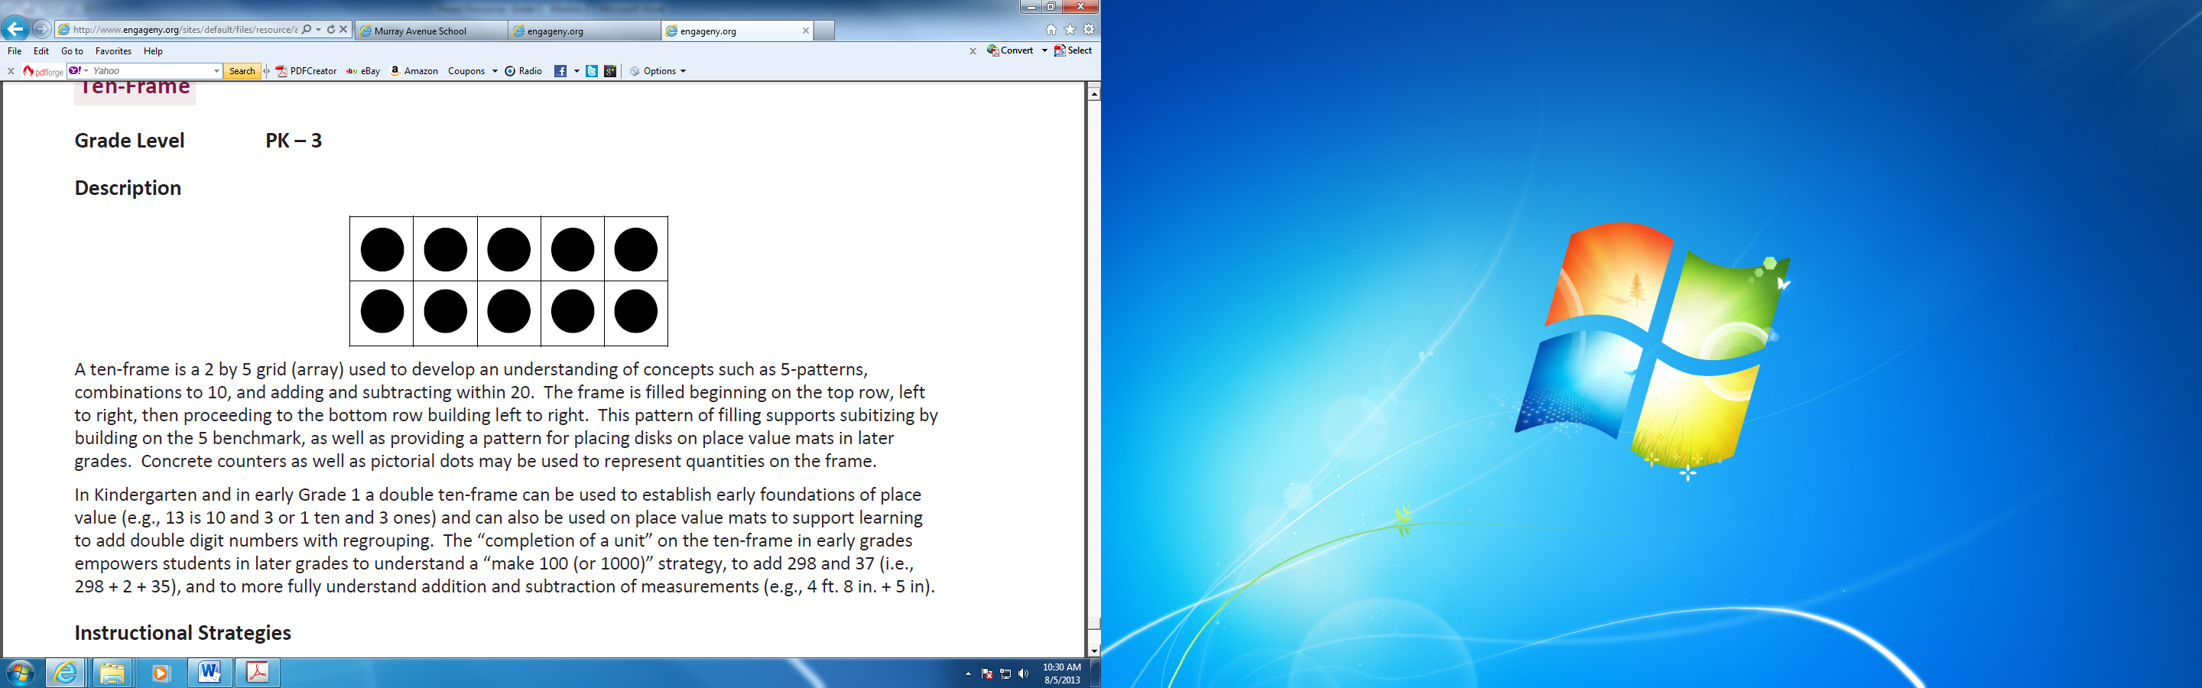

A **ten-frame** is a 2 by 5 grid (array) used to develop an understanding of concepts such as 5-patterns, combinations to 10, and adding and subtracting within 20.



The **place value chart** is a graphic organizer that students use to see the coherence of place value and operations between different units.

An **analog clock** is a clock that is not digital.





**Capacity** is the amount of liquid a particular container can hold.