***Examples of Concepts in Module 3: Second Grade***

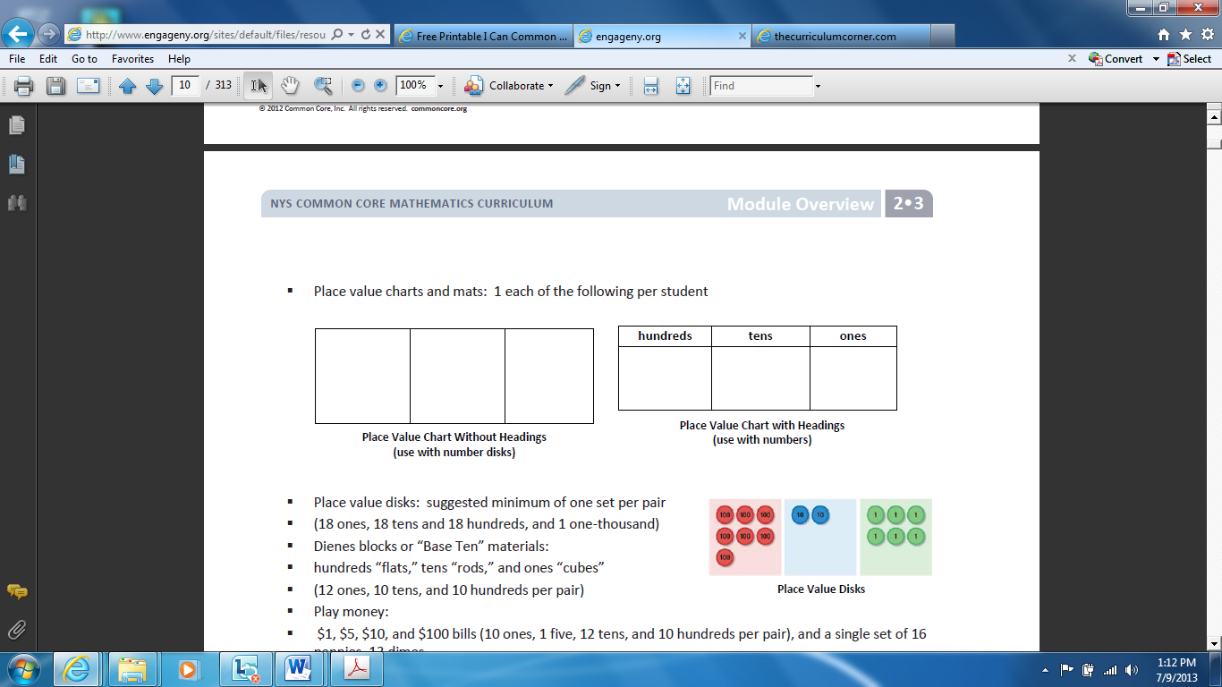Students will use **place value disks** to model the number of hundreds, tens, and ones in a given number.

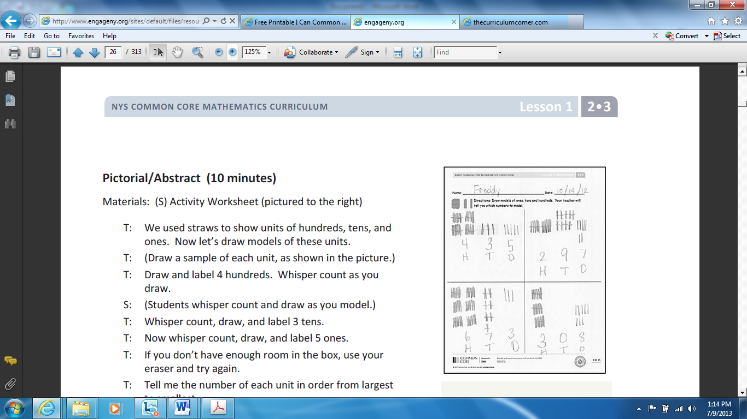

**Pictorial representations** will help students model units of hundreds, tens, and ones. They will draw and label the total number of each unit and count to make sure they are accurate.

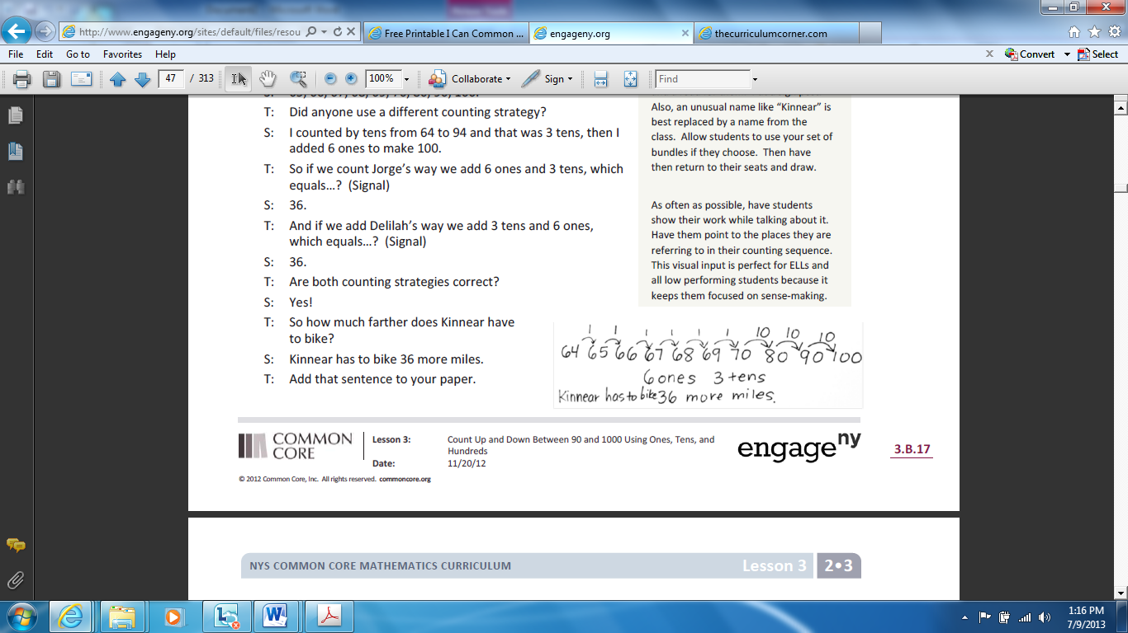**Number lines** are a flexible way for students to count forwards and backwards using units of 1 and 10 to find a sum or differences.

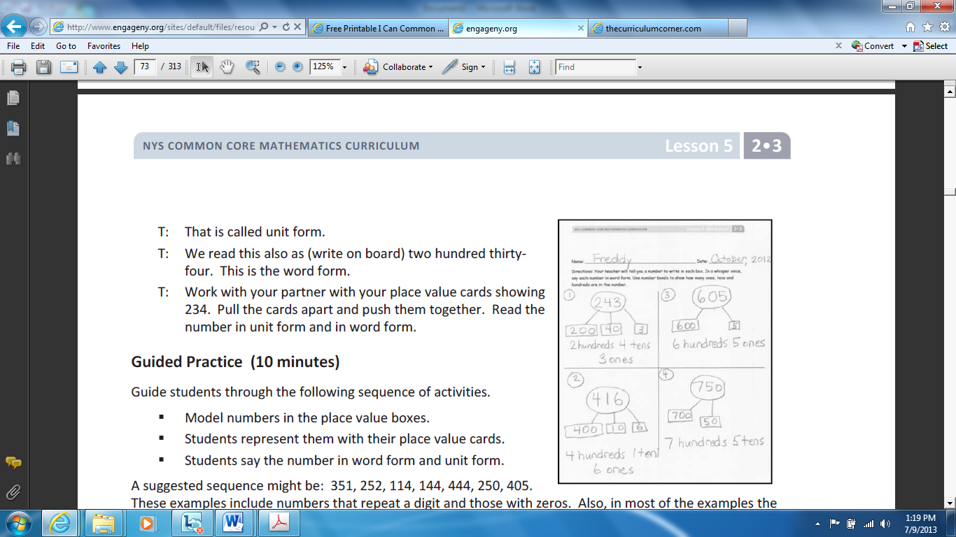

Students use **number bonds** to represent place value. The size of each box helps students understand the value of the digit in a three-digit number. Students will practice reciting and recording numbers in word and unit form.

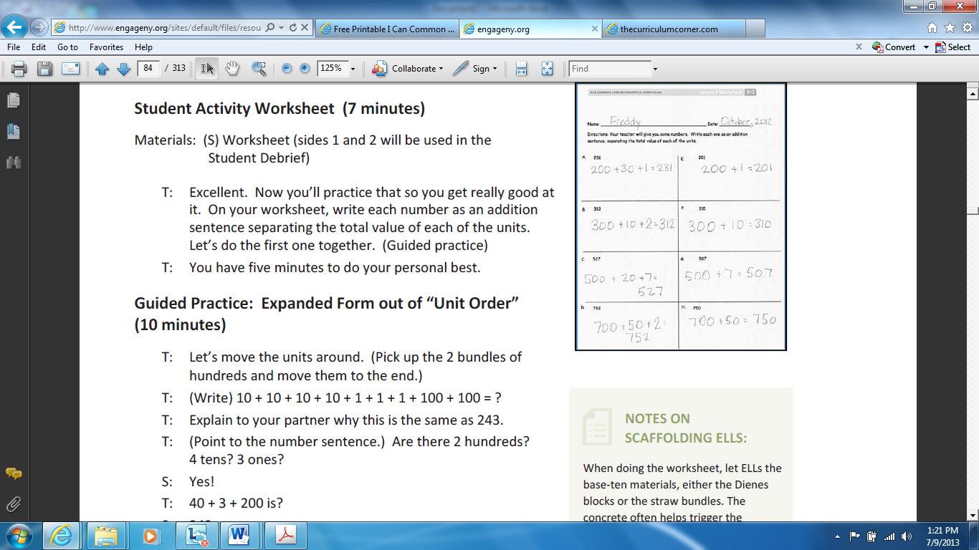Students will record numbers in **expanded form** to show their understanding of place value. They will write each number as an addition sentence seperating the total value of each of the units.

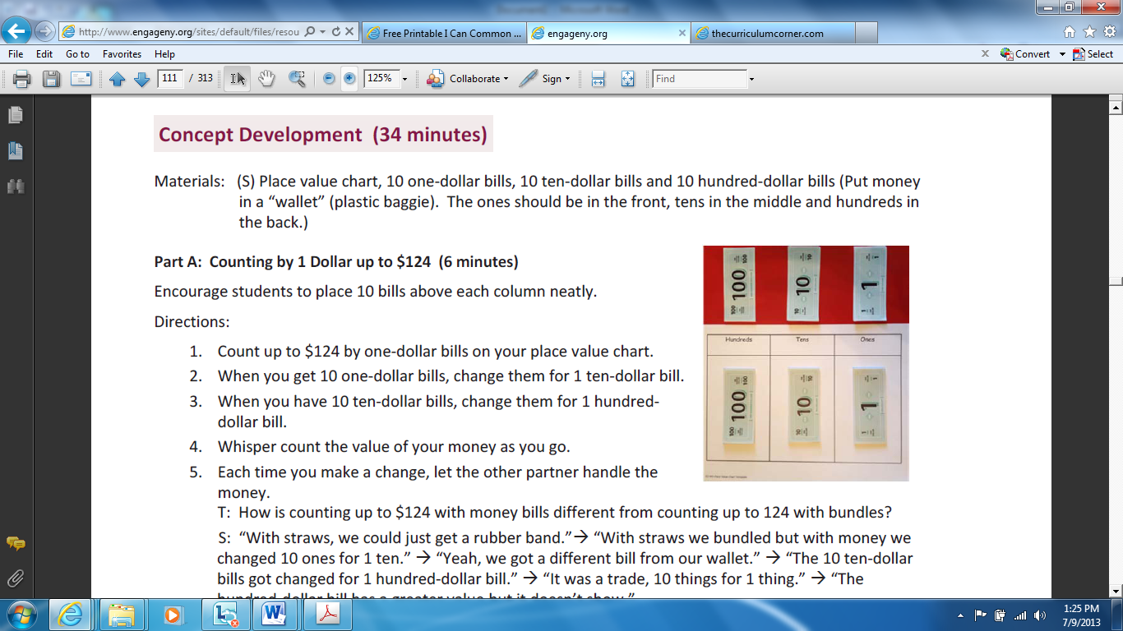

Students will use **$1, $10, and $100 bills** to further their understanding of place value. They will draw visual representaions of the bills to show their thinking.

Students can use **drawings of place value disks** to represent and explain their thinking while solving problems. Students record a statement to express the solution.

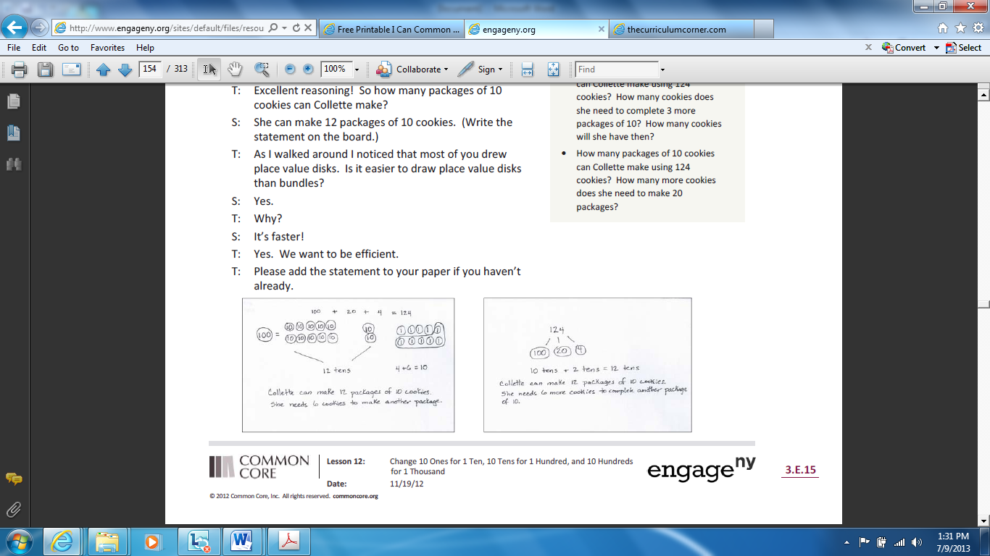

An **empty number line** helps students count by 100s, 10s, and 1s in order to count forwards and backwards.

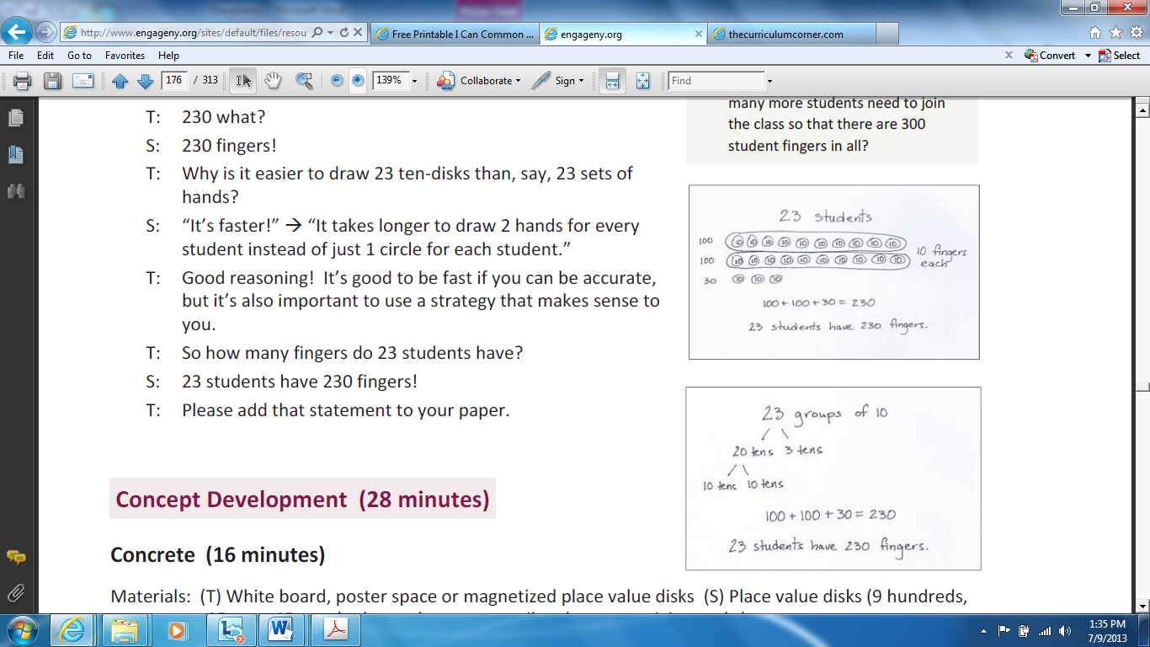Students follow the **Read Draw Write** process to solve and represent word problems. A variety of strategies and visual representations are modeled throughout the year. As students develop, they are encouraged to use strategies that are appropriate for their level of understanding. Students are encouraged to check their work to ensure accuracy. **Guiding questions** for the RDW process:

* 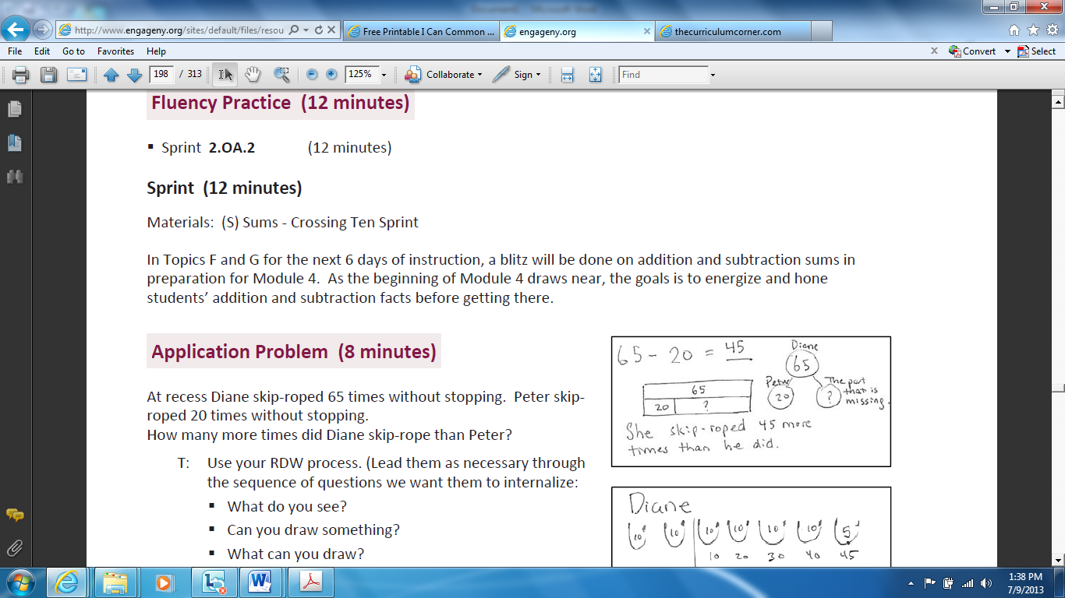What do you see?
* Can you draw something?
* What can you draw?
* What conclusions can you make from your drawings?
* What number sentence did you use to find the answer?
* Are you missing a part or a whole?