Examples of Concepts in Module 4: First Grade

Module 4 builds upon Module 2’s work with place value within 20, now focusing on the role of place value in the addition and subtraction of numbers to 40. Students will have various opportunities to study, organize, compare, and manipulate numbers within 40.

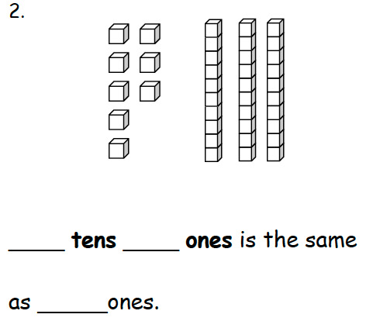
Having worked with creating a “ten and some ones” earlier in the year, students now recognize multiple tens and ones. Students use fingers, linking cubes, dimes, and pennies to represent numbers to 40 in various ways: from all ones to tens and ones. They use place value charts to organize units.

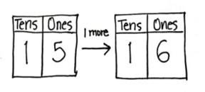

Students practice identifying 1 more, 1 less, 10 more, and 10 less, as they learn to add or subtract like units.

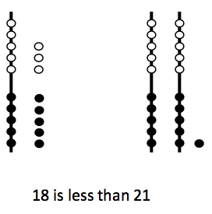
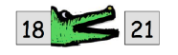
Students begin to cpmpare quantities and begin to use the symbols for greater than (<) and less than (>). Students demonstrate their understanding of place value when they recognize that 18 is less than 21 since 2 tens already have a greater value that 1 ten and 8 ones.

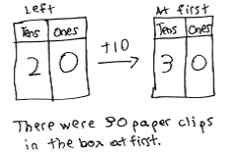
Students begin to focus on addition and subtraction of tens. Since students know that 3 + 1 =4, now they learn that 3 tens + 1 ten = 4 tens. This allows students to add and subtract a multiple of 10 from another multiple of 10.
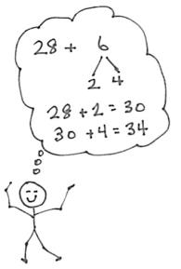
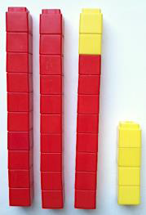

Students apply strategies of counting on and making ten to
larger numbers, this time making a ten that is built on a
structure of other tens. As shown, students use linking
cubes as a concrete representation of the numbers, write
a matching number sentence, and write the total in a place
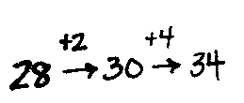
value chart. As they add cubes, students will see that sometimes you make a new ten,
for example, 33 + 7 = 40, or 4 tens.

Students work at a more abstract level by using dimes and pennies to model each addend. For instance, students model 14 cents using 1 dime and 4 pennies, and add 2 additional pennies or 2 additional dimes.
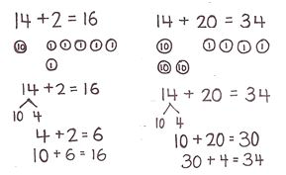
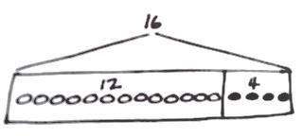
Students begin working with larger numbers and word problems. As they solve, they draw and box the two parts, and then include the numeral label within the box, producing tape diagrams. This enables them to quickly identify where the quantities can be found within a tape diagram. Students begin adding a bracket to identify the total. Students use tape diagrams to represent the part/part/total relationship when solving word problems within 20. Students will also explore number relationships as they notice and discuss how the size of the boxes relates to the size of each part.
total

Students are encouraged to READ, DRAW, WRITE when solving problems.
Read the word problem.
Draw a tape diagram and label.
Write a number sentence and a statement that matches the story.

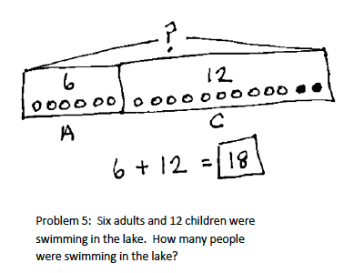
Example of a tape diagram:

Terminology

- Equal (=)
- Numerals
- Ones
- Tens
- > greater than
- < less than
- Place value (quantity represented by a digit in a particular place within a number)

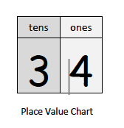
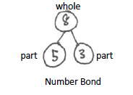
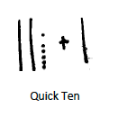
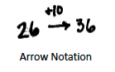
Representations:

