Examples of Concepts in Module 2: First Grade
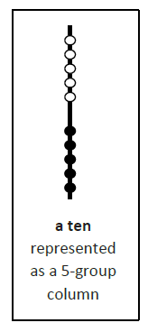

The image below demonstrates the Rekenrek as a unit of ten,
comprised of two 5 group columns. With previous work in
Module 1 of composing and decomposing groups to make
ten, students will utilize the image of the ten column as a
precursor to place value and the base ten system. Moving
forward, students will identify teen numbers as units of
ten and some ones thus introducing the concept of place
value.

The following representations utilize the five-group structure to build an understanding of the base ten system. Students will rely on the previous knowledge of these quick images grouped in fives, allowing them to quickly build a group of 10 and then add on individual ones.
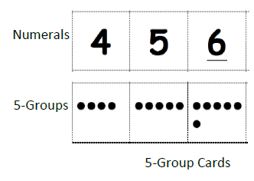
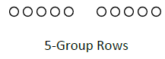

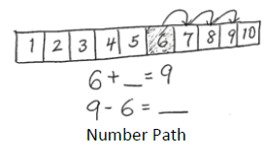
Students will also be introduced to a number path, to efficiently count on from a number visually noticing the motion of moving up or down a number line or number path.

