­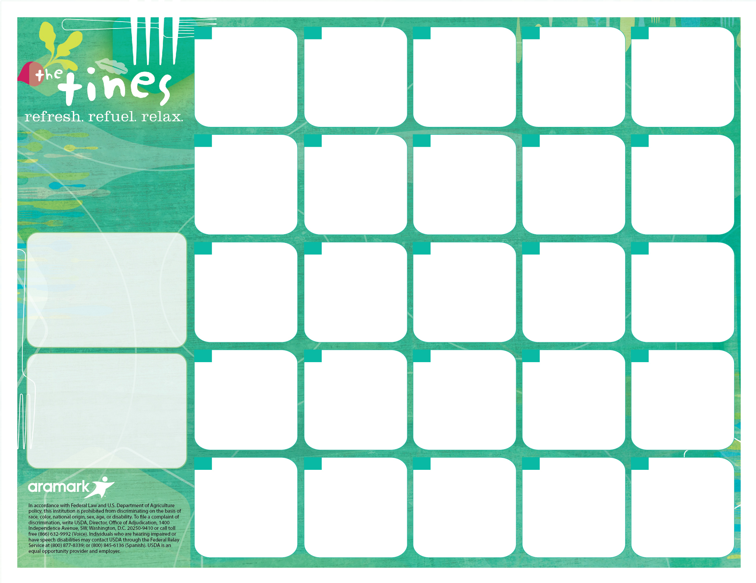

**More info…**

If you have any questions, please call Sandra Renken the Food Services Department at

(914) 220-3337

*Free or Reduced Lunch Program. To Apply, Visit mamkschools.org/parents-community/food-services.

**Additional Midday Meal Options (Offered Daily)**

**Made to Order Deli Bar*-** Boar’s Head Lower Sodium Cold Cuts, Reduced Fat Assorted Cheeses, Grilled Chicken (Plain or Barbecue), Tuna or Egg Salad and Fresh Veggies (Lettuce, Tomato and Onion) served on fresh, Whole Grain Bread (Rolls, Wraps, Sliced and Gluten-Free).

**Pizza Bar** - Cheese, Pepperoni, Veggie and a “Pie of the Day.” Cheese Calzones and Stromboli are also available on a weekly basis.

**Seasonal Salad\*\*** – A generous offering (1 cup) of Green Leaf Lettuce, Red Cabbage, Sliced Cucumbers, Carrots and Tomatoes with low-fat dressing. You may also purchase this salad with Grilled Chicken.

*Served with Bread/Grain.

**Salad Plates also Available – Tuna, Sliced Egg, Grilled Chicken and Chef.

“The Simple Way to Pay for School Meals.” – **myschoolbucks.com**

**Lunch pricing…**

$3.05 – Students / $3.75+Tax - Adults

$0.25 or FREE – FRLP* Participants

Water stations are available with all meals

All Lunches Include:

Protein, Bread/Grain, Vegetable, Fruit/Juice and Choice of Fat-Free White, Chocolate or 1% White (8 oz).

*Fresh Fruit Basket Offered Daily.

Whole Grain Pizza

WG Breadstick

Leafy Green Salad

1 Cup

Roasted Zucchini

Fruit Salad

**29**

All-Natural Breaded Chicken or Tofu Strips

Sautéed Spinach

Sweet Potato Wedges

WG Pasta Salad

Pear

**28**

Beef Burger or Veggie Patty on WG Roll

Sliced Tomato, Baby Spinach and Cheddar Cheese

Mixed Red Cabbage Cole Slaw

Banana

**26**

WG Spaghetti

w/Kale No-Nut Pesto or Italian Meat Sauce

Roasted Lentils

Roasted Carrots

Grapes

**25**

WG Cheese Ravioli

w/Vegetable Tomato Sauce

WG Garlic Breadstick

Roasted Lentils

Apple

**20**

Chicken or Veggie and Cheese WG Quesadilla

Spanish Rice

Black Beans

Sweet Corn

Salsa/Guacamole

Melon Wedge

**19**

WG, 3 Cheese Macaroni

Spinach & Apple Salad

Vegetarian Beans

WG Roll

Apple

**7**

3 Bean Chili

Cornbread

Brown Rice

Sweet Potatoes

Cucumber Salad

Pear

**6**

**No Meals**

**Served**

**Today**

**5**

**Labor Day**

**No School**

**4**

**MUFSC**

**High School**

**September, 2017**

**Welcome Back Students!**

**##**

**##**

**##**

**##**

**##**

Bean & Cheese WG Burrito

Spanish Rice

Salsa/Guacamole

Green Tomato Salad

Watermelon

**27**

WG Noodle Bowl w/Chicken,

Sliced Ginger Carrots & Sugar Snap Peas

Green Beans

Pineapple

**18**

**Rosh Hashanah**

**No School**

**21**

**Rosh Hashanah**

**No School**

**22**

Veggie & Cheese Quiche on WG Crust

Citrus Green Salad

Grape Tomatoes

Grapes

**11**

Beef or Veggie Tacos w/2 oz. Cheese

Tomato Salsa

Brown Rice

Black Beans

Sweet Corn

Banana

**12**

Breaded Fish or Baked Tofu Sticks

Sweet Potato Wedges

Roasted Cauliflower

Orange Wedges

**13**

Roasted Chicken w/Curried Vegetables

Couscous

Chickpeas

WG Roll

Orange

**14**

Whole Grain Pizza

WG Breadstick

Leafy Green Salad

1 Cup

Cucumbers

Fruit Salad

**15**

Villa Maria Pizza

WG Garlic Breadstick

Leafy Green Salad

Cup

Carrot Sticks ½ Cup

Fruit Salad

**8**