­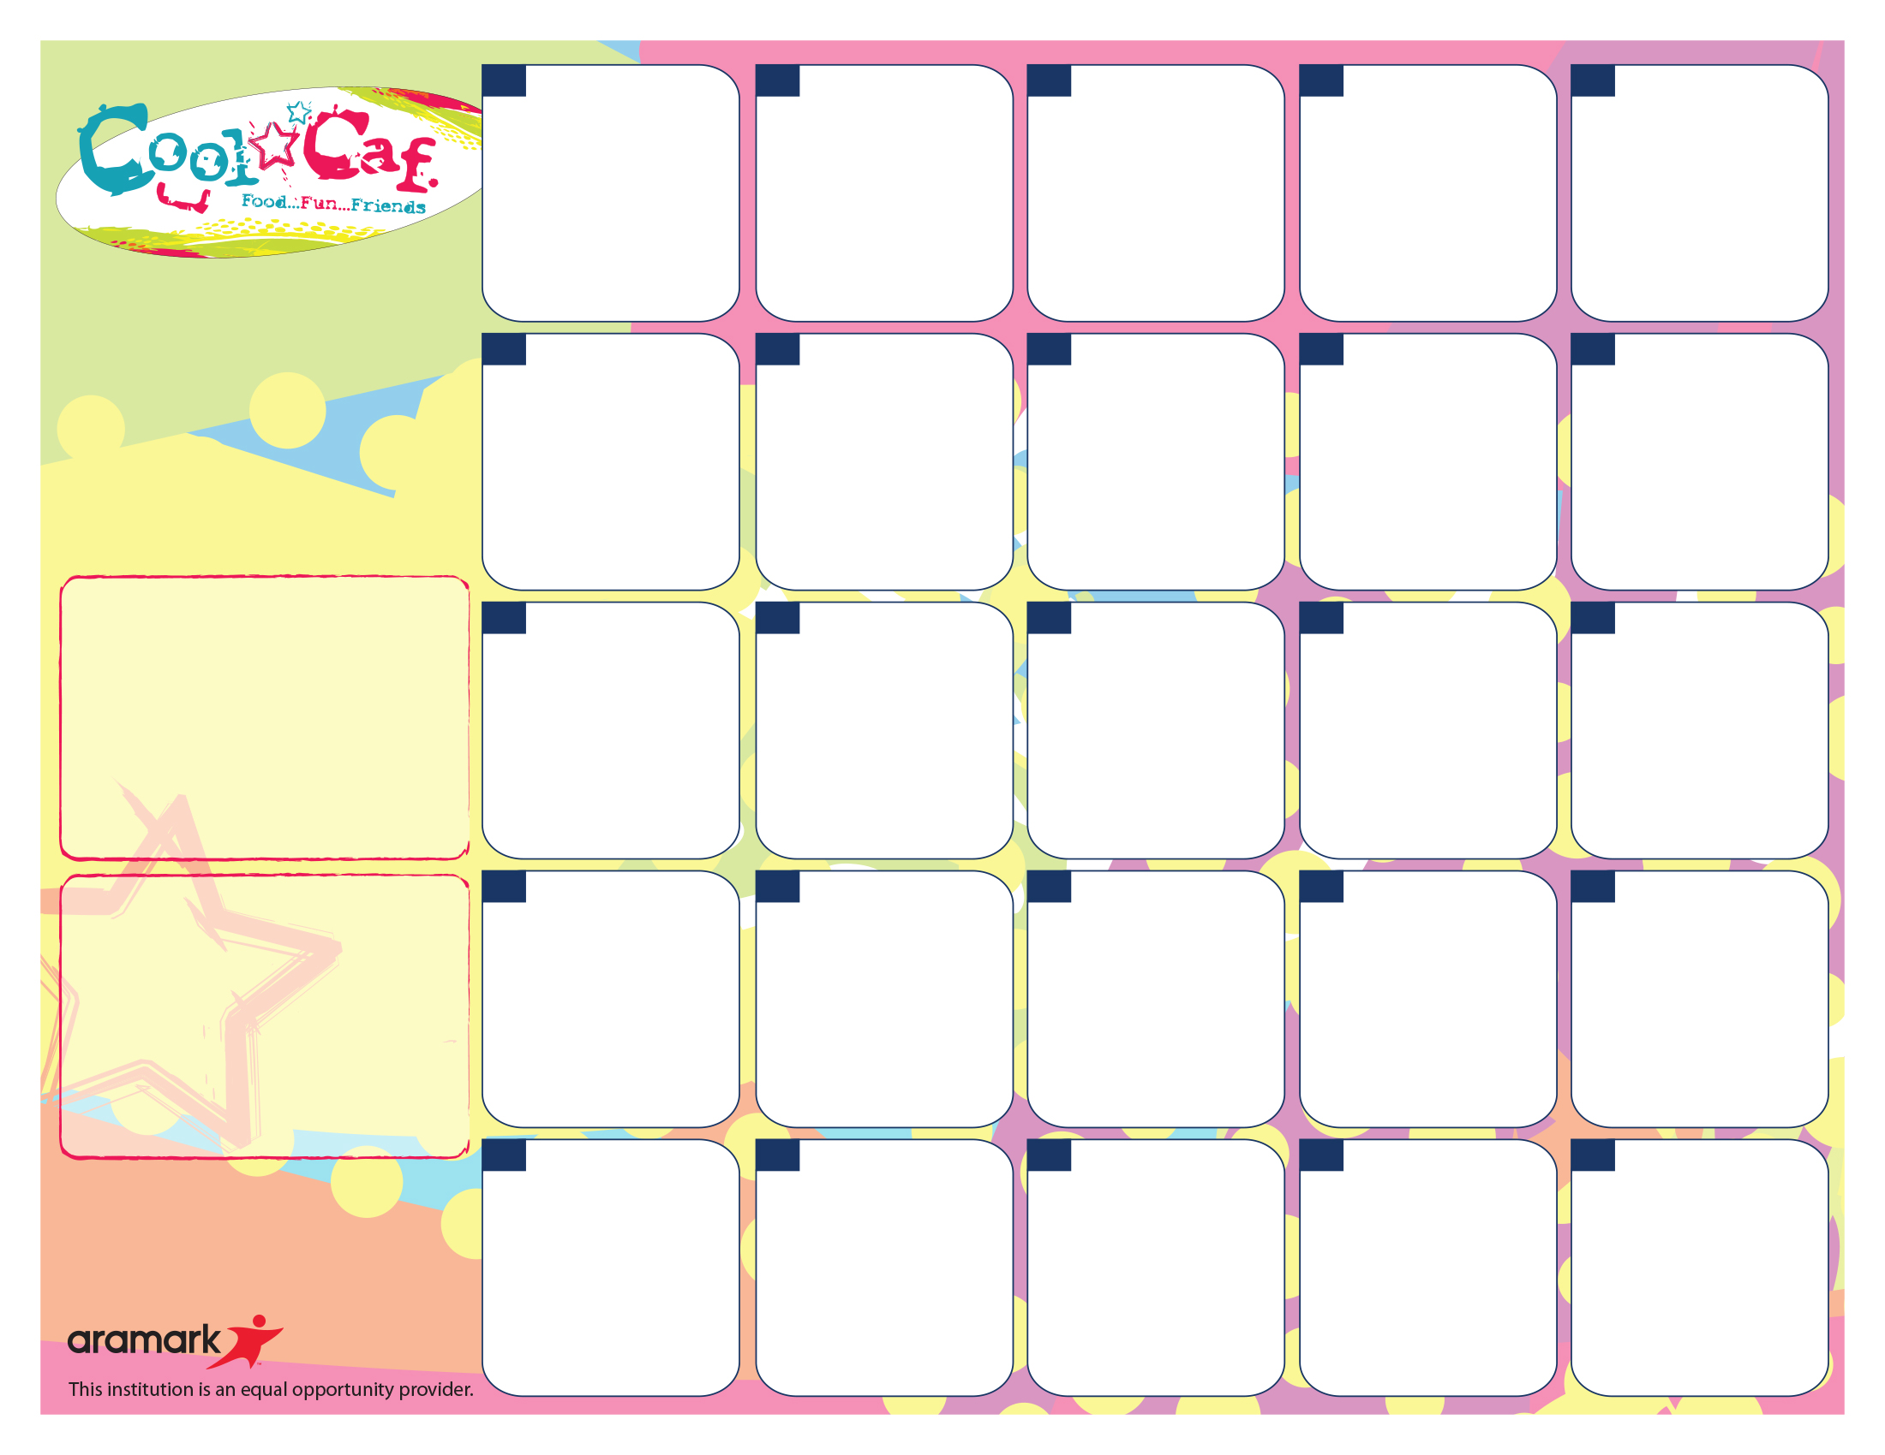

**Sandwiches:**

M – Turkey & Cheese or w/o Cheese

T – Ham & Cheese or w/o Cheese

W – Salami & Cheese or w/o Cheese & Cheese or w/o Cheese

Th – Rst Chicken Breast & Cheese or w/o Cheese

F – Bologna & Cheese or w/o Cheese

**Salads:**

M – Chef Salad

T – GrilledChicken Cesear

W – Tuna

Th – Hard Boiled Egg

F – SW Chicken / Cheese

**WG = Whole Grain**

**Wellness Wednesday**

Bean & Cheese WG Burrito

Spanish Rice

Tomato Salsa

Guacamole

Tomato Salad over Dark Greens

Watermelon

**27**

**Wellness Wednesday**

Breaded Fish or Baked Tofu Sticks

Sweet Potato Wedges

Roasted Cauliflower

Orange Wedges

**13**

Tacos w/Beef or Veggies w/1oz Cheese

Tomato Salsa

Brown Rice & Black Beans

Sweet Corn

Banana

**12**

**More info…**

If you have any questions, please call Sandra Renken the Food Services Department at (914) 220-3337

*Free or Reduced Lunch Program. To Apply, Visit mamkschools.org/parents-community/food-services.

**Lunch pricing…**

$2.80 – Students / $3.75+Tax - Adults

$0.25 or FREE – FRLP* Participants

Lunch Includes :

Protein, Bread/Grain , Vegetable, Fruit/Juice and Choice of Fat-Free White, Chocolate or 1% White (8 oz).

WG Spaghetti w/Kale No-Nut Pesto or w/Italian Tomato Meat Sauce

Roasted Lentils

Roasted Carrots

Grapes

**25**

**Daily Lunch Offerings:**

Side Salad - 1 Cup Dark, Leafy Greens Topped w/Seasonal Produce

Fruits and Vegetables - A Variety of Fresh Fruits and Vegetables in 1/2 Cup Portions

Sunflower Seed Spread & All-Fruit Spread Sandwiches on WG Bread

Yogurt Parfait: All-Natural Yogurt w/Granola & Fruit

SunButter & Jelly Offered Monday-Friday

***\*\* Water stations are available with all meals\*\*\****

Pay for School Meals.” – **myschoolbucks.com**

Baked WG Chicken Fingers or Tofu Strips

Sautéed Kale

Sweet Potato Wedges

WG Pasta Salad

Pear

**28**

Beef Burger or Veggie Patty on a WG Roll

Sliced Tomato, Baby Spinach & Cheddar Cheese

Mixed Red Cabbage Cole Slaw

Banana

**26**

**Wellness Wednesday**

WG Cheese Ravioli w/Vegetable Tomato Sauce

WG Garlic Toast

Roasted Lentils

Apple Wedges

**20**

Chicken or Veggie and Cheese WG Quesadilla

Spanish Rice

Black Beans

Sweet Corn

Guacamole

Melon Wedge

**19**

Mixed Vegetable & Cheese Quiche w/WG Crust

Citrus Green Salad

Grape Tomatoes

WG Roll

Grapes

**11**

**Wellness Wednesday**

3 Bean Chili

Cornbread

Brown Rice

Sweet Potatoes

Cucumber Salad

Pear

**6**

Baked, WG Macaroni

& 3 Cheeses

Spinach & Apple Salad

Vegetarian Beans

WG Roll

Apple Wedges

**7**

Regardless of portion size, the FSMC is responsible for meeting all requirements under the Final Rule Nutrition Standards in the National School Lunch and School Breakfast Programs. This includes Min-Max calories, Saturated Fat, Sodium, specific component offers for all fruits, vegetables, grains, meat/meat alternates and milk.

**##**

**##**

**##**

**##**

**##**

WG Pizza

WG Garlic Breadstick

Green Salad

Red and Green Pepper Strips

Fresh Fruit Salad

**29**

WG Noodle Bowl w/Chicken

Sliced Ginger Carrots & Sugar Snap Peas

Green Beans

Pineapple

**18**

**Rosh Hashanah**

**No School**

**21**

**Rosh Hashanah**

**No School**

**22**

Roasted Chicken Curried Vegetables

Couscous

Chickpeas

WG Roll

Orange Wedges

**14**

WG Pizza

WG Garlic Breadstick

Green Salad

Cucumbers

Fresh Fruit Salad

**15**

**Labor Day**

**No School**

**4**

WG Pizza

WG Garlic Breadstick

Green Salad

Carrot Sticks

Fresh Fruit Salad

**8**

**First Day of School**

**No Lunch**

**5**

**Chatsworth Elementary**

**Lunch Menu**

**September, 2017**