­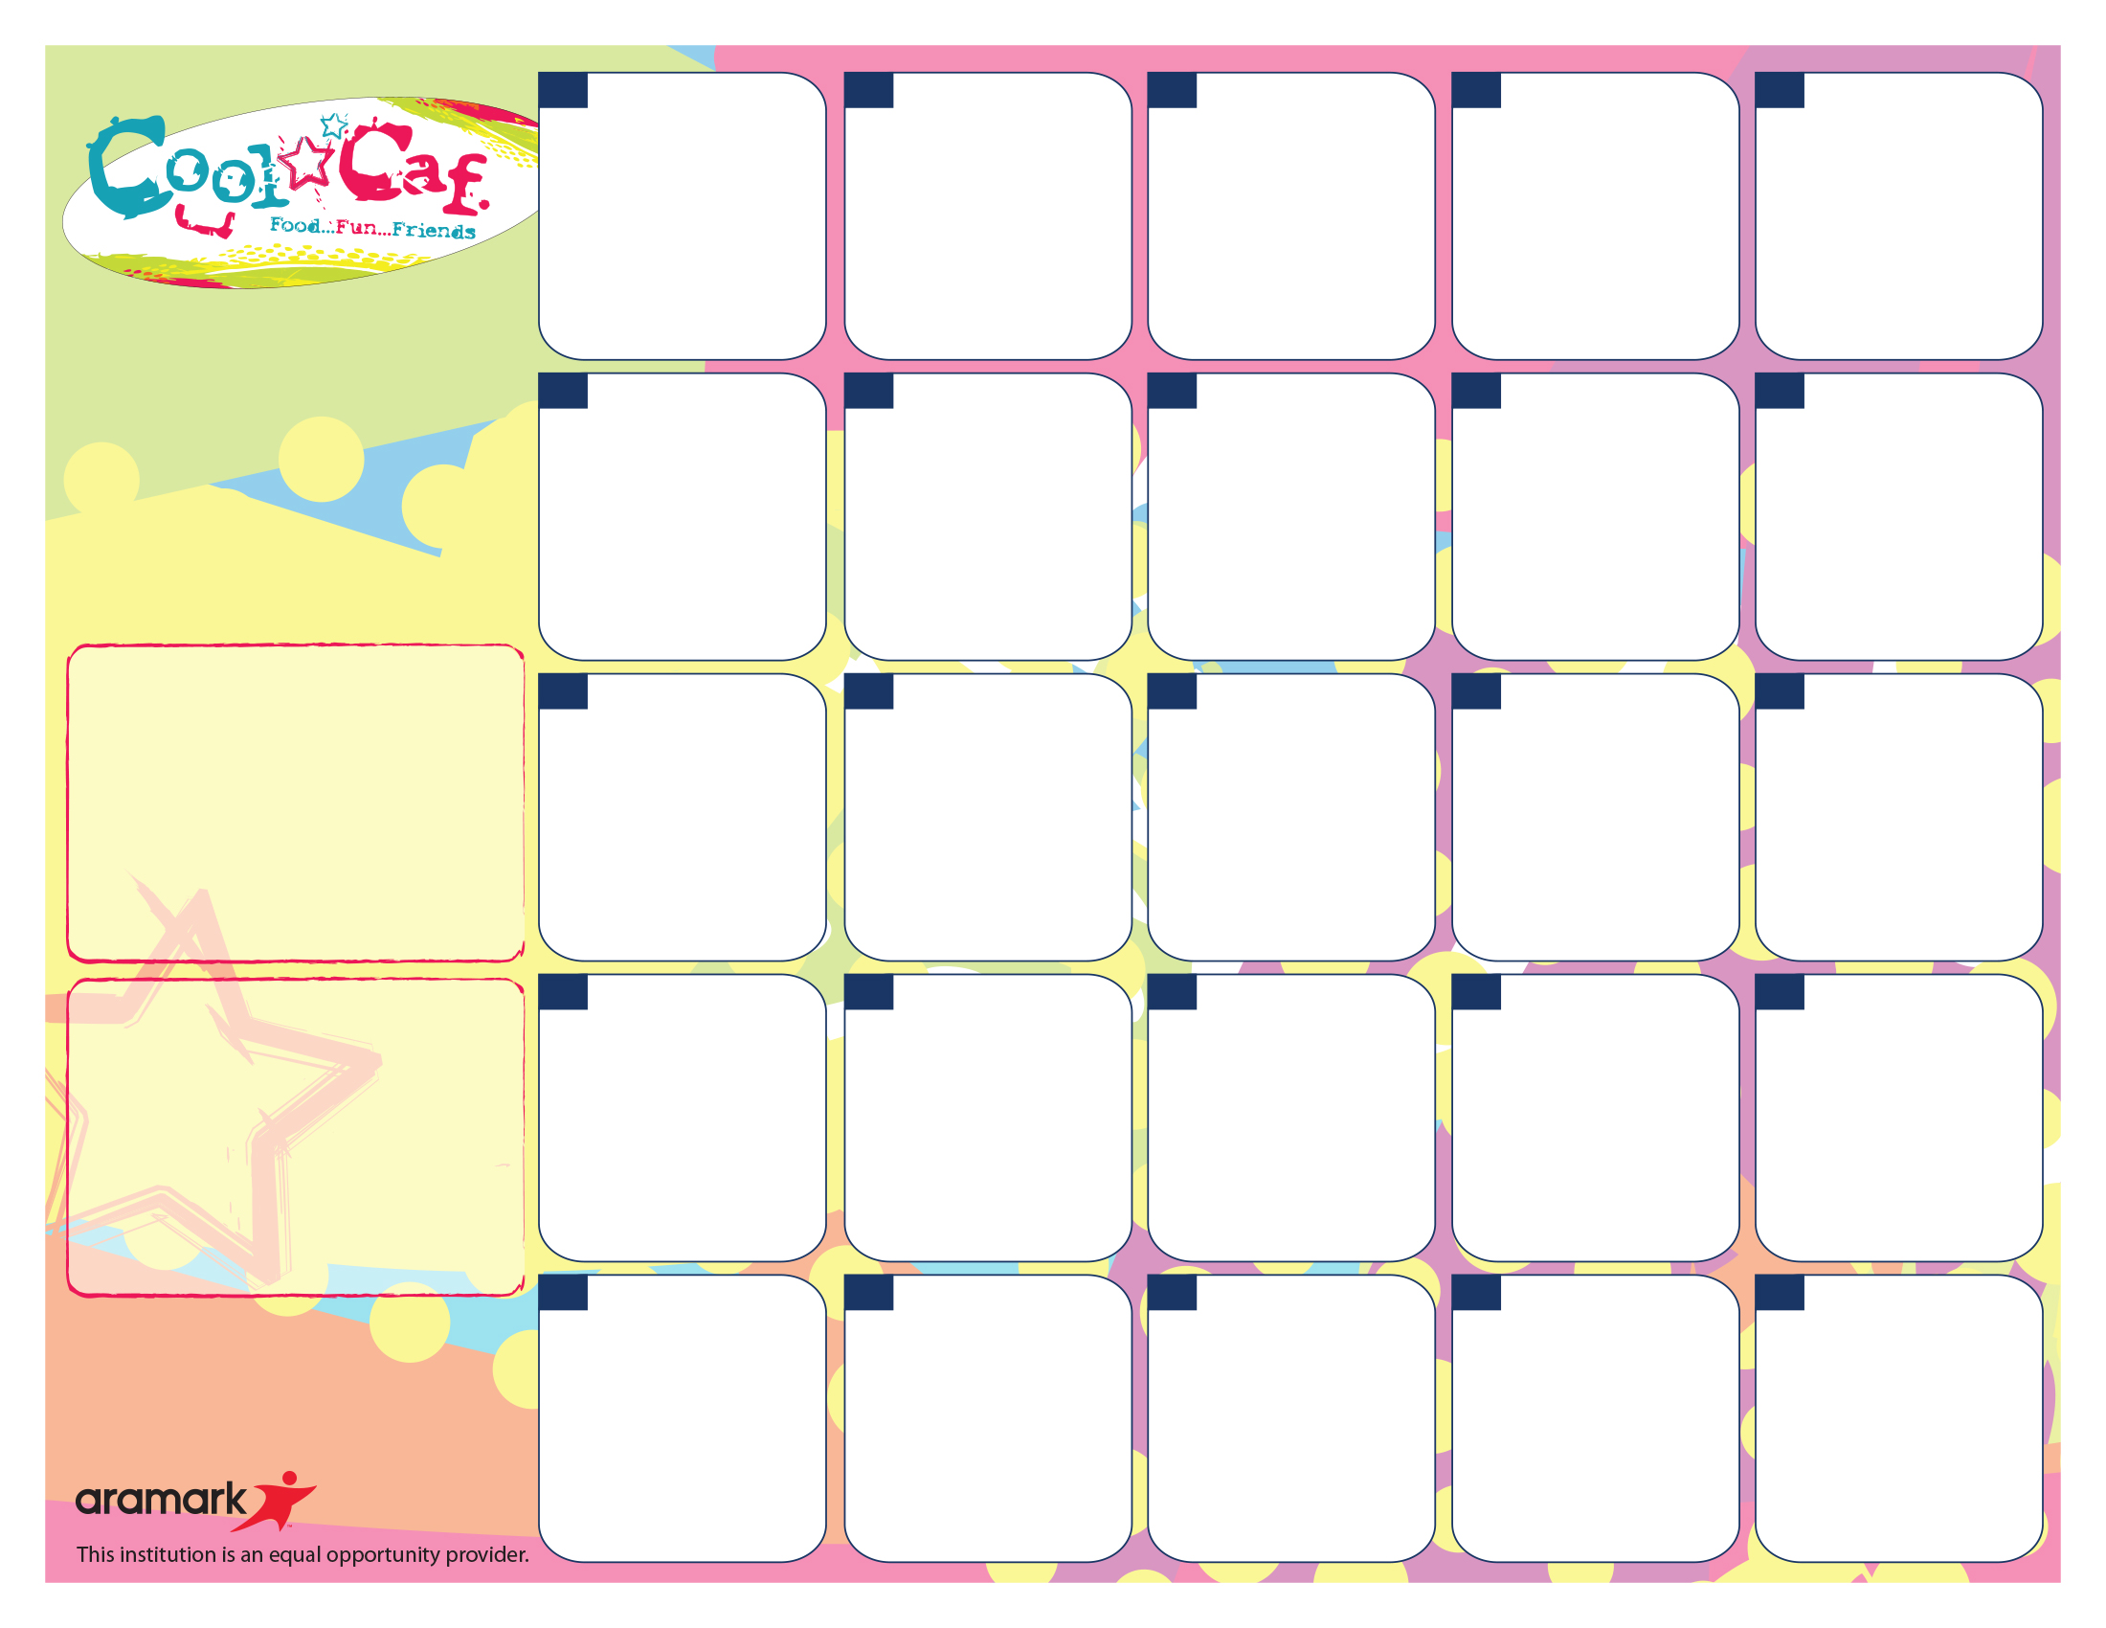

**Breakfast pricing…**

$1.20 – Students / $2.20+Tax - Adults

$0.25 or FREE – FRLP* Participants

Breakfast Includes:

Meat/Protein Alternate (varies daily), Bread/Grain, Fruit/Juice and Choice of Fat-Free White or 1% White (8 oz).

**Daily Breakfast Offerings**

WG Fresh Bagels w/Cream Cheese or Butter WG Assorted Muffins

All-Natural Yogurt w/Granola or Fresh Fruit Mozzarella Cheese Sticks

Assorted, WG Cereals w/Cheese Stick or Graham Crackers

*Fresh Fruit Daily at Breakfast, may be in Conjunction w/100% Fruit Juice*

*All Served w/Milk (Antibiotic & Hormone-Free 1% White and Skim*

*\*\*\* Water stations are available with all meals\*\*\**

“The Simple Way to Pay for School Meals.” – **myschoolbucks.com**

Regardless of portion size, the FSMC is responsible for meeting all requirements under the Final Rule Nutrition Standards in the National School Lunch and School Breakfast Programs. This includes Min-Max calories, Saturated Fat, Sodium, specific component offers for all fruits, vegetables, grains, meat/meat alternates and milk.

**More info…**

If you have any questions, please call Sandra Renken the Food Services Department at (914) 220-3337

*Free or Reduced Breakfast Program. To Apply, Visit mamkschools.org/parents-community/food-services.

**##**

**##**

**##**

**##**

**##**

Egg & Cheddar Omelet on WG English Muffin

4 oz, 100% Fruit Juice

AND

Fresh Fruit

**25**

WG Apple Fruit Strudel Stick

4 oz, 100% Fruit Juice

AND

Fresh Fruit

**26**

Egg, Turkey Sausage & Cheese on WG Kaiser Roll

4 oz, 100% Fruit Juice

AND

Fresh Fruit

**27**

French Toast w/Fruit Compote

4 oz, 100% Fruit Juice

AND

Fresh Fruit

**28**

Breakfast Quesadilla w/Cheddar Cheese Country Ham & Fresh Tomatoes

4 oz, 100% Fruit Juice

AND

Fresh Fruit

**29**

WG Waffles w/Fruit Compote

4 oz, 100% Fruit Juice

AND

Fresh Fruit

**18**

Ham & Egg on WG Kaiser Roll

4 oz, 100% Fruit Juice

AND

Fresh Fruit

**19**

Warm Cornbread

4 oz, 100% Fruit Juice

AND

Fresh Fruit

**20**

**Rosh Hashanah**

**No School**

**21**

**Rosh Hashanah**

**No School**

**22**

Egg & Cheese on WG English Muffin

4 oz, 100% Fruit Juice

AND

Fresh Fruit

**11**

Breakfast Pizza w/Eggs, Ham & Peppers

4 oz, 100% Fruit Juice

AND

Fresh Fruit

**12**

WG French Toast w/Fruit Compote

4 oz, 100% Fruit Juice

AND

Fresh Fruit

**13**

WG Waffles w/Fruit Compote

4 oz, 100% Fruit Juice

AND

Fresh Fruit

**14**

Egg, Turkey Sausage & Cheese on WG Kaiser Roll

4 oz, 100% Fruit Juice

AND

Fresh Fruit

**15**

**Labor Day**

**No School**

**4**

WG Fluffy Pancakes w/Fruit Compote

4 oz, 100% Fruit Juice

AND

Fresh Fruit

**7**

Egg, Turkey Sausage & Cheese on WG Kaiser Roll

4 oz, 100% Fruit Juice

AND

Fresh Fruit

**8**

Egg & Cheese on WG English Muffin

4 oz, 100% Fruit Juice

AND

Fresh Fruit

**6**

WG Waffles w/Fruit Compote

4 oz, 100% Fruit Juice

AND

Fresh Fruit

**5**

**Mamaroneck Avenue Elementary**

**Breakfast Menu**

**September, 2017**