***Examples of Concepts in Module 2: Fifth Grade***

**Tape Diagrams**

**Tape Diagrams** are drawings that look like a segment of tape, used to illustrate number relationships. Your child might be more familiar with the term “bar model”, which is just another name for the same diagram. The tape diagram is used to help children visualize a problem and determine problem solving steps. They are especially helpful when solving multi-step word problems. After drawing the tape model, students are able to determine the correct algorithm(s) to use to find the answer.

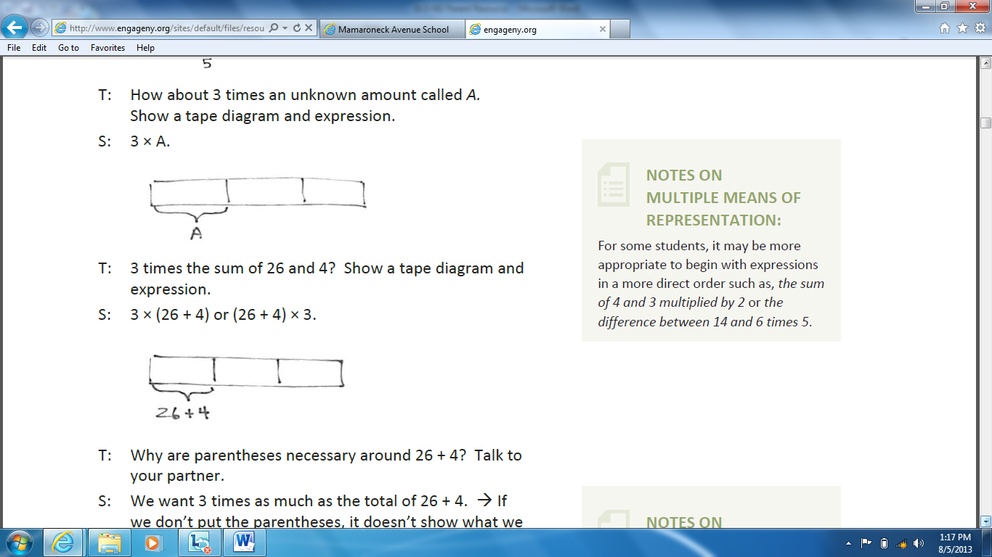

**Area Model**

The **area model** for multiplication is a pictorial way of representing multiplication. In the area model, the length and width of a rectangle represent factors, and the area of the rectangle represents their product. It can be used for both whole numbers and decimals, as shown in the examples below.

Whole Number Example Decimal Example

