Examples of Concepts in Module 5: Fourth Grade

In this module, students build on their Grade 3 work with unit fractions as they explore fraction equivalence and extend this understanding to mixed numbers. This leads to the comparison of fractions and mixed numbers and the representation of both in a variety of models. Benchmark fractions (like one half, one third, two thirds, one fourth etc.) play an important part in students’ ability to generalize and reason about relative fraction and mixed number sizes. Students then have the opportunity to apply what they know to be true for whole number operations to the new concepts of fraction and mixed number operations.

As students work with decomposition, they represent familiar unit fractions as the sum of smaller unit fractions.

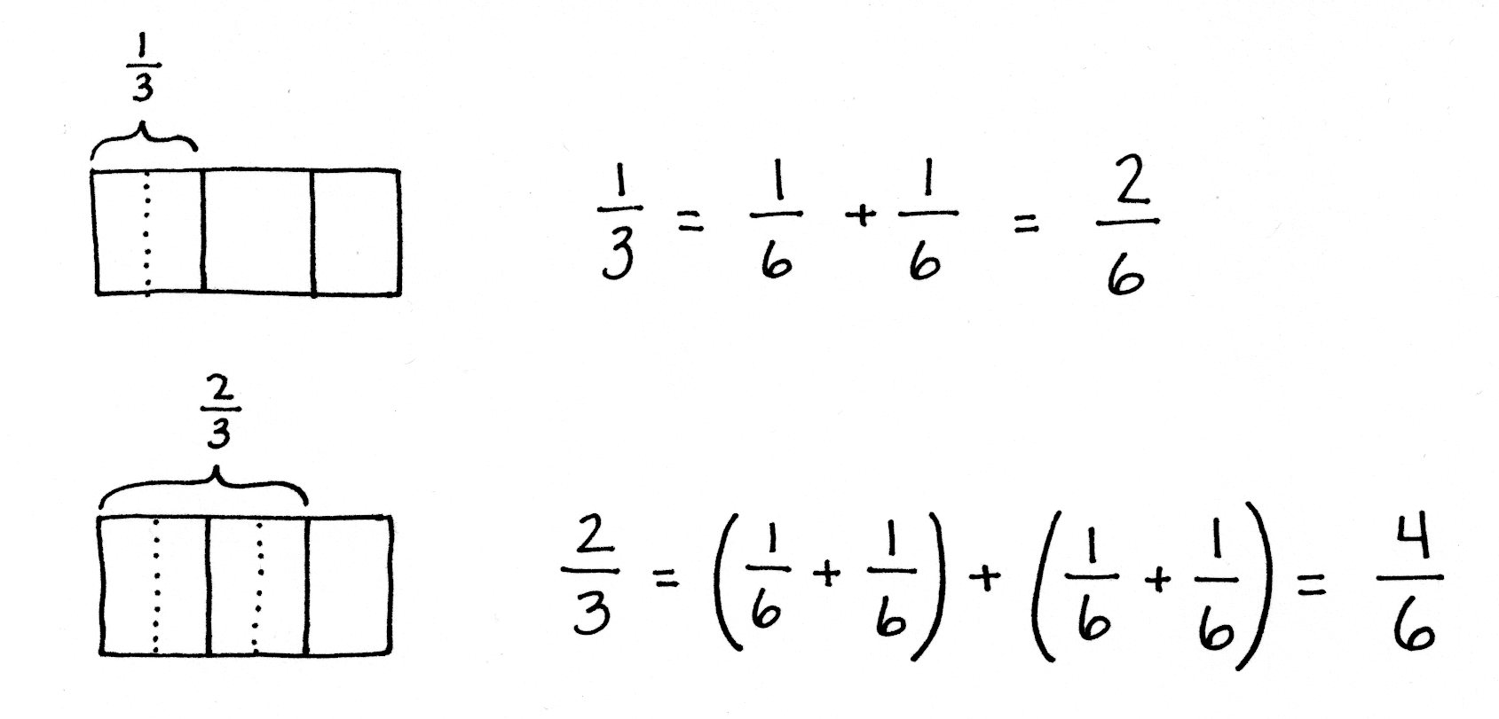

Students use tape diagrams and area models to use multiplication to create an equivalent fraction comprised of smaller units. Based on the use of multiplication, they reason that division can be used to create a fraction comprised of larger units (or a single unit) that is equivalent to a given fraction.

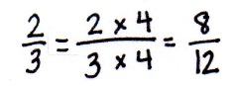
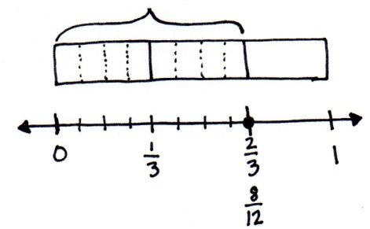
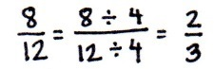
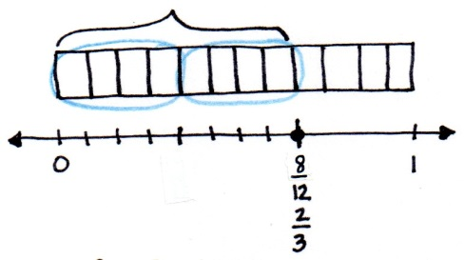
In Grade 3, students compared fractions using fraction strips and number lines with the same denominators. Now, they expand upon comparing fractions by reasoning about fractions with unlike denominators. Students use the relationship between the numerator and denominator of a fraction to compare to a known benchmark (e.g., 0, $\frac{\text{1}}{\text{2}}$ , or 1) on the number line. Alternatively, students compare using the same numerators. They find that the fraction with the greater denominator is the lesser fraction, since the size of the fractional unit is smaller as the whole is decomposed into more equal parts, e.g., $\frac{\text{1}}{\text{5}}$ > $\frac{\text{1}}{\text{10}}$ therefore $\frac{\text{3}}{\text{5}}\text{ >}\frac{\text{3}}{\text{10}}$.

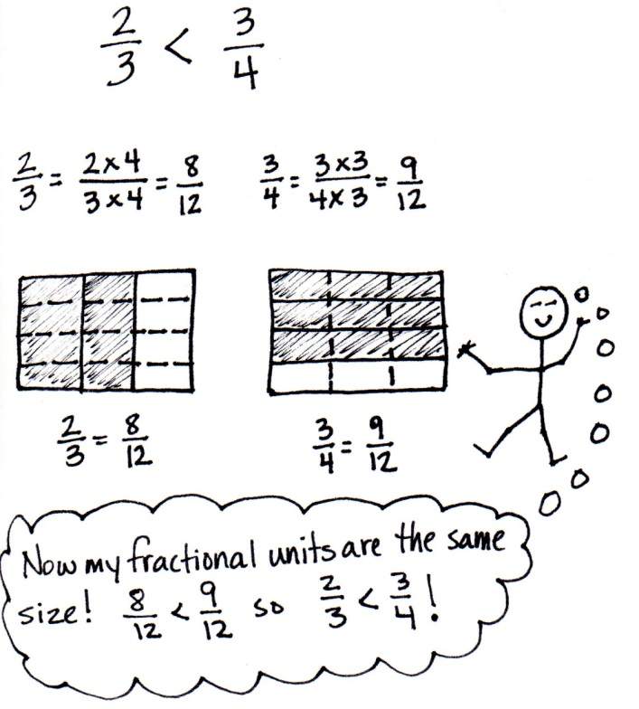
Comparison Using Like Numerators
Comparison Using Like Denominators

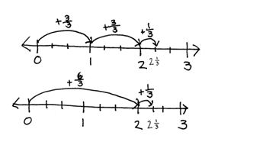
Students apply their understanding of whole number addition (the combining of like units) and subtraction (finding an unknown part) to work with fractions
