***Examples of Concepts in Module 2: Fourth Grade***

**Solving Problems in Multiple Ways** is an expectation for students throughout the year. This module provides an opportunity for students to practice mental math calculations as well as the addition and subtraction algorithms used in module 1. Students reason by choosing to convert between mixed and single units before or after the computation.

In the example below, a child was asked to solve the problem: 10 kg -2 kg 250 g:

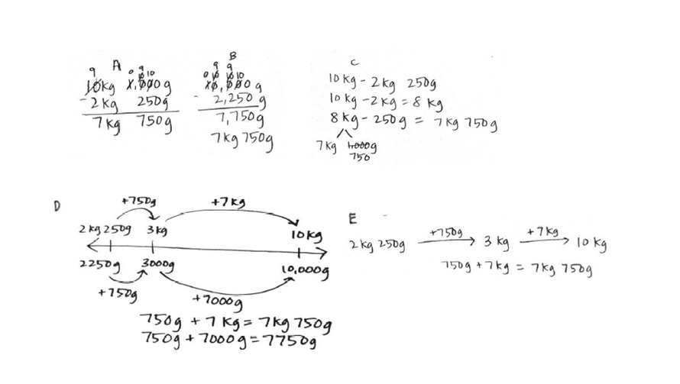

**Number Bonds** are pictorial representations of part-part-whole relationships and show that within a part-whole relationship, smaller numbers (the parts) make up larger numbers (the whole). Number bonds are used to support mental math techniques, as shown in the examples below:

