***Examples of Concepts in Module 1: First Grade***

Children will learn to use **Piano Fingers** when counting up to ten. They will have their hands in front of them with their fingers extended (as if about to play a piano). Counting from left to right with their fingers (beginning with left pinky and moving across hands toward right pinky) is an organized way for them to use their most readily-available tool! This type of counting also mimics the number line/path, which will be used in later lessons.

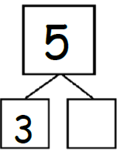

**Number Bonds**: Number Bonds are a way to represent a math fact and a way to represent the know and unknown quantities in a problem. Students write the total in the large circle and the addends in the small circles of the bond. This is another way to create a visual representation of the **embedded numbers** (3 and 2 in the example on the top left) within a given number.

**Ten Frames** are a visual representation of a number. They can be used to show the two parts in a number under ten (5 and 1 in the example below) and to visualize and show different ways to make a number (if the ten frame on the right had two rows of three filled in).

They can also be used for “Make Ten” math

facts: 6 + = 10 or 10 - = 6.

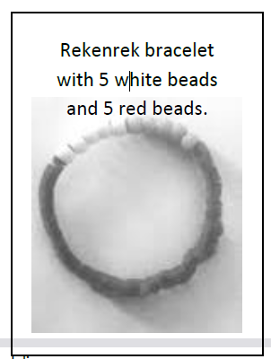

**Rekenrek bracelets** are manipulatives used as another representation of composing and decomposing numbers.

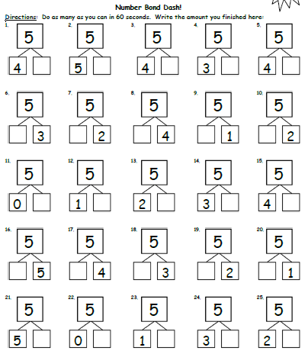

**Sprints** are designed to develop fluency.

They should be fun, adrenaline-rich

activities that intentionally build energy

and excitement.

When solving **word problems** at this time of the year, students will be asked to represent the known and unknown quantities in the problem (the example below shows this in a number bond), use drawings to find the solution, write an equation/number sentence for the problem, and write a sentence to answer the question in the problem.

