Count Back

Materials:

- Die with dots or numbers (1-6)

- Any counters (circles, squares, cubes, chips)

- “Count Back” game board

How to play:

Children take turns:

- Rolling the die

- Counting back 1 from the number they roll (i.e., If I roll 6, I count back 1 to get 5)

- Saying the difference

- Covering the difference on their side of the game board

The winner is the first player to cover all the numbers on his or her side of the game board.

0 | 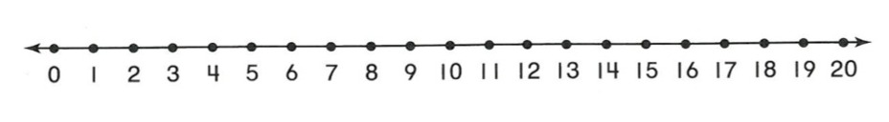  Count Back 1 | 5
1 |  | 4
2 |  | 3
3 |  | 2
4 |  | 1
5 |  | 0

